Converting a SEG-Y File

The latest version of WinDisp now provides a means for converting SEG-Y seismic files to a form which can be used in normal displays or in the 3D Modeller.

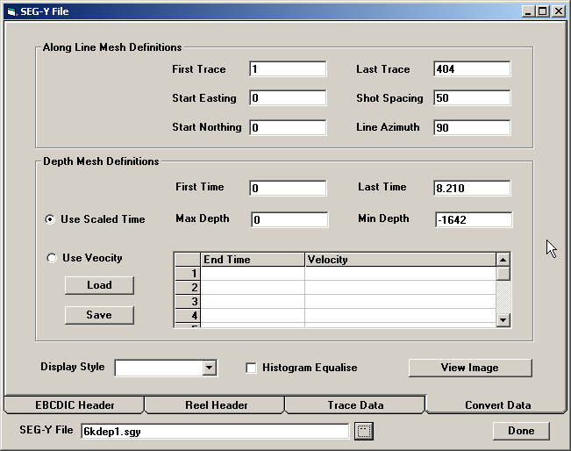
To use it, start WinDisp as usual, start a new layout, click on the Utilities> SEG-Y File Utility menu item to bring up the SEG-Y File form:

Click on the File Selection button at the bottom of the form, navigate to where you have stored the SEG-Y files and select the file of interest. Once the required file has been selected, the program scans the file to ensure that the format is valid. Currently WinDisp only supports files which contain a standard 3200 byte EBCDIC header followed by a 400 byte reel header followed by multiple trace records. The trace records may optionally contain a trace header, but they must all be of the same length.

If the file has been decoded successfully, click on the EBCDIC Header tab to display the header:

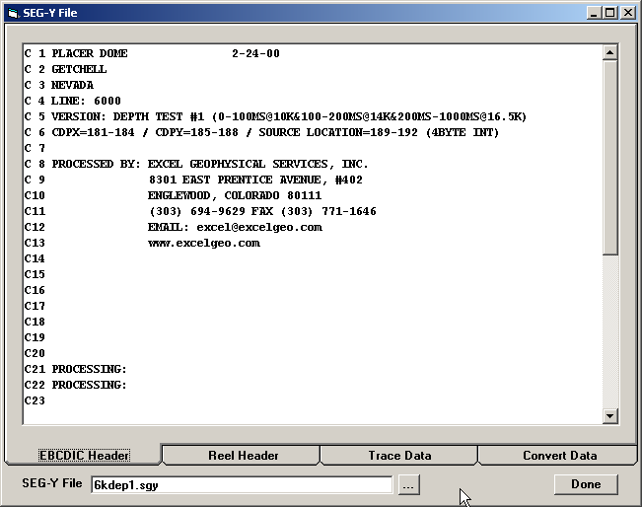
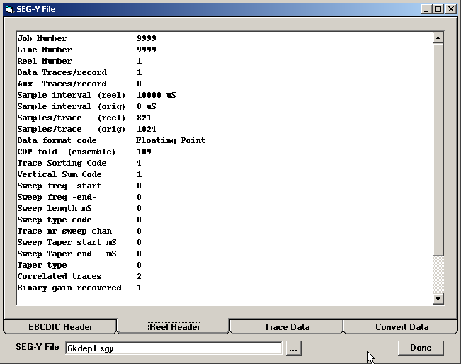
Click on the Reel Header tab will display the Reel header:

Click on the Trace Data tab will display the Trace data records:
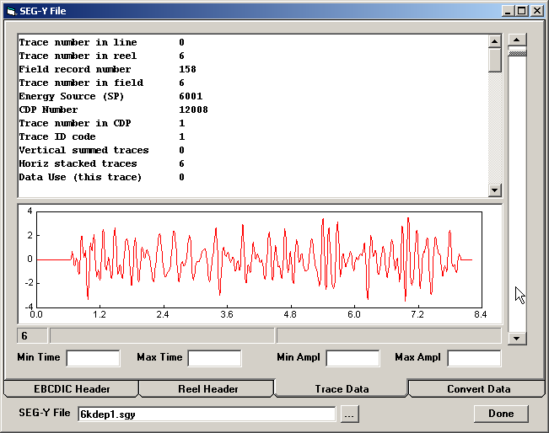

This form displays the Trace header in the top part of the form and the converted trace data in the bottom part of the form. To facilitate the examination of the traces, you may set the minimum and maximum times to be displayed and the minimum and maximum amplitudes. The scroll bar at the right of the form can be used to select which trace to display.

When the mouse is moved in the trace graph, the first panel in the status bar displays the trace number, the second panel displays the delay time and the third panel displays the amplitude.

Once you have verified that the data has been decoded correctly, return to the Convert Data tab. This form has a number of data values which you need to sepcify in order to convert the seismic data to a usable form.

First Trace

Use this value to select the first trace to export. The default (and minimum) value is 1.

Last Trace

Use this value to specify the last trace to export, The default (and maximum) value is the number of traces read from the data file

Start Easting

This value specifies the start grid coordinate to be assigned to the first exported trace

Shot Spacing

Use this value to specify the separation in m between consecutive shot points. Note that it is assumed that the shots are uniformly spaced and recorded in order in the SEG-Y file. The SEG-Y file does have information about the actual shot locations, but this appears to be generally unreliable, so is not used at present.

First Time

This value specifies the first time slice to be exported. The default (and minimum) value is 0. The SEG-Y file may contain information that can be used to determine the actual time delay for the first time slice, but this information is not used at present.

Last Time

This value specifies the last time slice to be exported. The default (and maximum) value is the total number of time slices times the sample interval.

Use Scaled Time

Select this option to perform a simple time to depth conversion. If this option is selected, you need to specify the minimum and maximum depths for the exported minimum and maximum times:

Min Depth

This is the depth associated with the first time slice to be exported. When the export grid is generated the depth is converted to elevation (ie multiplied by –1).

Max Depth

This is the depth associated with the last time slice to be exported. When the export grid is generated the depth is converted to elevation (ie multiplied by –1).

Use Velocity

If this option is selected, you need to specify the velocity-time transform function. To do this enter the end-time for each slice (in milliseconds) in the first column of the velocity profile grid and enter the corresponding velocity (in m/sec) in the second column. Keep entering end-times and velocities for all bands that you wish to specify. If the last end time does not cover the full trace, the last specified velocity band is extended to cover the entire trace duration. The start of the first time band is assumed to be at 0ms delay.

Save Velocity Profile

The values you enter on the Velocity Profile Grid will be lost when the form is closed. To save you having to reenter this information again, click on the Save Button and specify a file name to save the velocity profile.

Load Velocity Profile

Click on the Load button to read a previously saved velocity profile function. Select the file to read and the values in the file will be loaded onto the velocity profile grid.

Here is an example of what the form will look like with the above values specified:

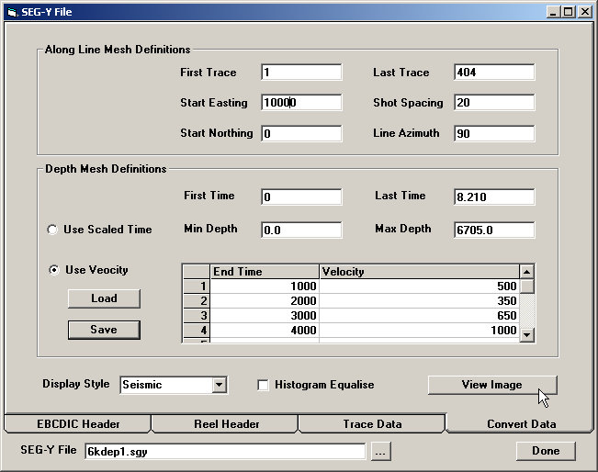
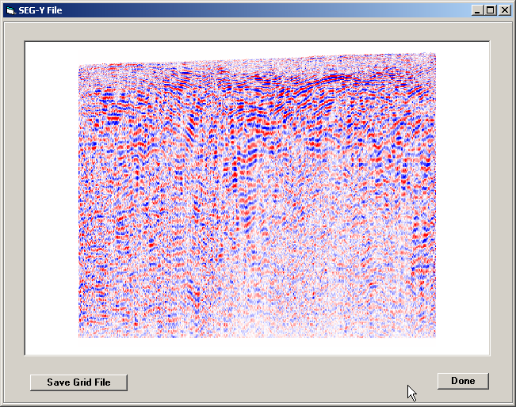

Once all the required information has been specified, click on the View Image button and the data on the form will be check and then used to convert the trace data to a grid file:

If the grid is acceptable, click on the Save Grid File button, specify a file name and location and the seismic data will be written out a Geosoft binary grid file. This grid file can then be displayed in the usual way in WinDisp or loaded up as a vertical section in the 3DModeller.

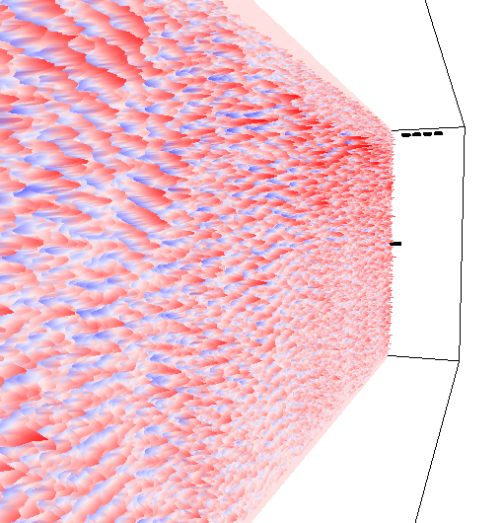

To help in assessing the grid file, the Display Style list can be used to select Seismic, Colour or Greyscale. The seimic option is illustrated above with red assigned to hign, blue to low and white in between. The colour option is the usual blue to red rainbow and the greyscale option is the usual black to white.

The Histogram Equalise option can be used to perform a colour stretch on the image to highlight low releif feature in the image.

Note that the Start Northing and Line Azimuth values are not used in the current version, but will be used for generating VRML output in the next version.

